|  |
| --- |
| 新东方在线英语学习 |
| 新概念 2 册 |
| Lesson31 |



扫一扫。更多有趣的英语资讯。

1. success n. 成功successful adj. successfully adv. succeed v.
2. bicycle n. 自行车

tricycle n. 三轮车

recyclable adj. 可循环使用的

# Lesson 31 单词讲解

1. save v. 积蓄

save money

save money for the rainy days save time

save the game 保存游戏进度

savings n. 存款，积蓄

1. employ v. 雇 佣
2. employment n. 雇佣，就业unemployment n. 失业

Succeed in doing sth

unemployment rate 失业率

# Key points:

**复习一般过去时／过去进行时**

used to do sth.过去常常做某事

# Lesson 31 课文&语法讲解

* 1. Yesterday afternoon Frank … was telling me about his experiences …

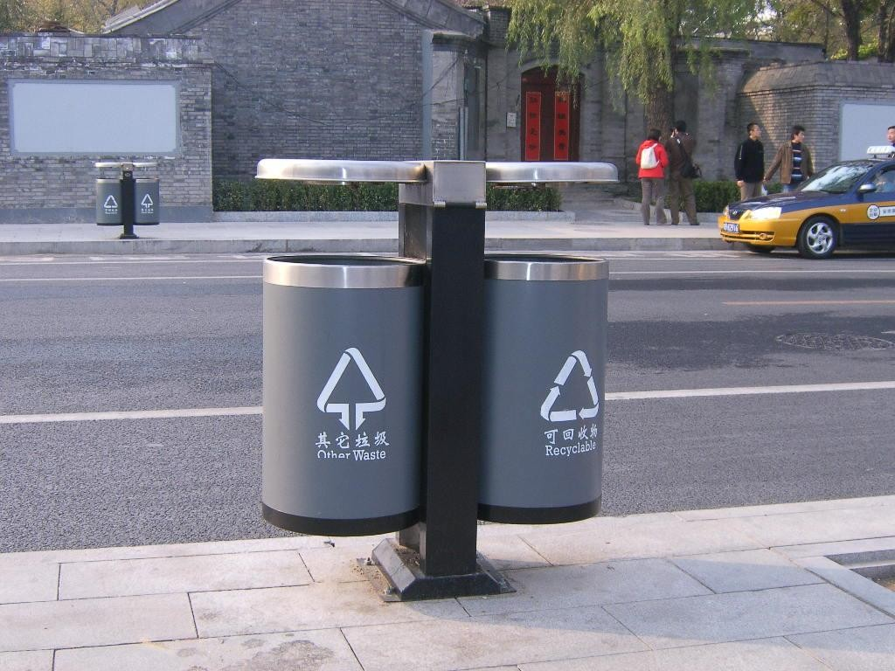

* 1. Before he retired, Frank was the head of a … business company … head n. 头 ／ “头儿”
  2. … but as a boy he used to work in a small shop. I used to drink a lot of coffee.

We used to live in the countryside.

People used to be happy when they were young.

* 1. It was his job to repair bicycles …

= To repair bicycles was his job.

To travel around the world is my dream.

= It is my dream to travel around the world. It is very important to study English.

It is necessary to think about the future. It is my honor to be here.

* 1. … at that time he used to work fourteen hours a day.
  2. He saved money … and in 1958 he bought a small workshop of his own. his own workshop

a small workshop of his own

* 1. In his twenties Frank used to make spare parts …
  2. In a few years the small workshop had become a large factory … become became become

come came come

* 1. He was still smiling when the door opened …
  2. She wanted him to repair their grandson’s bicycle!

# Lesson 31 知识拓展

**Key points:**

1. **used to do sth.**
2. **it 作形式主语**

**to do 作真正的主语**

We used to see each other , but I haven’t heard from him since last year.

* 1. especially
  2. regularly
  3. particularly
  4. approximately (2012 辽宁 22)

We used to see each other , but I haven’t heard from him since last year.

1. especially
2. regularly
3. particularly
4. approximately (2012 辽宁 22)

used to do sth.

* Tony usually worked late.

= Tony used to work late.

* I was always late for school.

= I used to be late for school. used to do sth.

* People were very honest in the old days.

= People used to be very honest in the old days.

* The students often borrowed books in the old library.

= The students used to borrow books in the old library.

* used to do sth.
* China is stronger
* My student works harder than before.

than it was.

than it used to be. than before.

than he did.

than he used to do. used to do sth.

The traffic in Beijing is heavier

* + than before.
  + than it was.
  + than it used to be.

used to do sth.

Nowadays we do more exercises to keep fit

* + than before.
  + than we did.
  + than we used to do.

It was his job to repair bicycles …

形式主语 真正的主语

* 每天读书是个好习惯。
* It is a good habit to read every day.

to read a book / books to do some reading

It was his job to repair bicycles …

形式主语 真正的主语

* 对于人们来说每天休息好是很重要的。
* It is important to have a good rest every day.

It is hard for the Greek government to get over the present difficulties it gets more financial support from the European Union.

1. if
2. unless
3. because
4. since (2012 福建 30)

It is hard for the Greek government to get over the present difficulties it gets more financial support from the European Union.

1. if
2. unless
3. because
4. since (2012 福建 30)

